**Crop diversity at the global scale**

**Introduction:**

-There are at least 50 000 species of plants that are suitable for human consumption, yet fewer than 300 species make their way into the market (*Jacques, 2012*)

-20 plant species comprising 90% of the world's [calories](https://www.sciencedirect.com/topics/biochemistry-genetics-and-molecular-biology/calorie) (*Massawe et al., 2016, Nelson et al., 2016*)

- A comprehensive study of global food trends reported that human diets worldwide have grown 36% more similar in composition over the past five decades (*Khoury, 2014*)

-Increase crop diversification is mentioned as “ An Unexploited Treasure Trove for Food Security” (*Massawe et al., 2016* + *cortinovis et al., 2020*)

-an increasing number of agronomy and ecology scientific papers focus on crop diversification + more and more papers are studying minor species (*Hammer et al., 2001*)

- Yet, the concept of diversification and a precise point on the species considered by agronomic research are yet incomplete (*Hufnagel et al., 2020*)

Aim: Provide a global map of the species used/promoted/studied in the academic field of agronomy and their temporal evolution.

**Material and methods:**

(black: done : orange: TODO (?) )

Data base:

1. We systematically retrieved the primary studies used in the meta-analysis on crop diversification identified in (an updated version) Beillouin et al 2019a,b = 136 meta-analyses.
2. We systematically characterized each primary study by their doi, country, species and type of crop diversification considered. We considered not only cash crops, but also trees (e.g. in agroforestry systems) and associated species grown in and around the fields (e.g. grass strips).
3. The traits and characteristics of each species have been detailed (based on <https://www.try-db.org/de/InfoBySpecies2.php> ? +

<https://agupubs.onlinelibrary.wiley.com/action/downloadSupplement?doi=10.1029%2F2007GB002947&file=gbc1454-sup-0003-t01.txt>)

Analyses:

1. Which diversity indicator should be used?

-use Bray–Curtis dissimilarity from each country ? cf (Khoury et al., 2014).

-Shannon index, …. ?

2. Analyze the species for each diversification strategies (agroforesterie, cover crops, rotation,…)

3.. Comparison of research efforts and area under cultivation:

Area of cultivation of 175 crops come from Monfreda et al., 2008.

**Results**

Data base:

* 6231 primary studies characterized (from 136 meta-analyses)
* 25412 observations (= species X primary studies)
* 2416 species identified and characterized.
* 7 types of crop diversification identified.



Fig 1. Total number of species analyzed per country.

* Maybe not the best indicator (here: total nb of species). But, the number of primary studies largely differ between countries (USa have the most Primary studies). Use a diversity index? Map to be compared to compared to https://www.ncbi.nlm.nih.gov/pmc/articles/PMC6364885/#pone.0209788.ref007 and/or hub.tw/https://doi.org/10.1073/pnas.1313490111
* Better if we use the genus (Family?) rather than the species?

a.

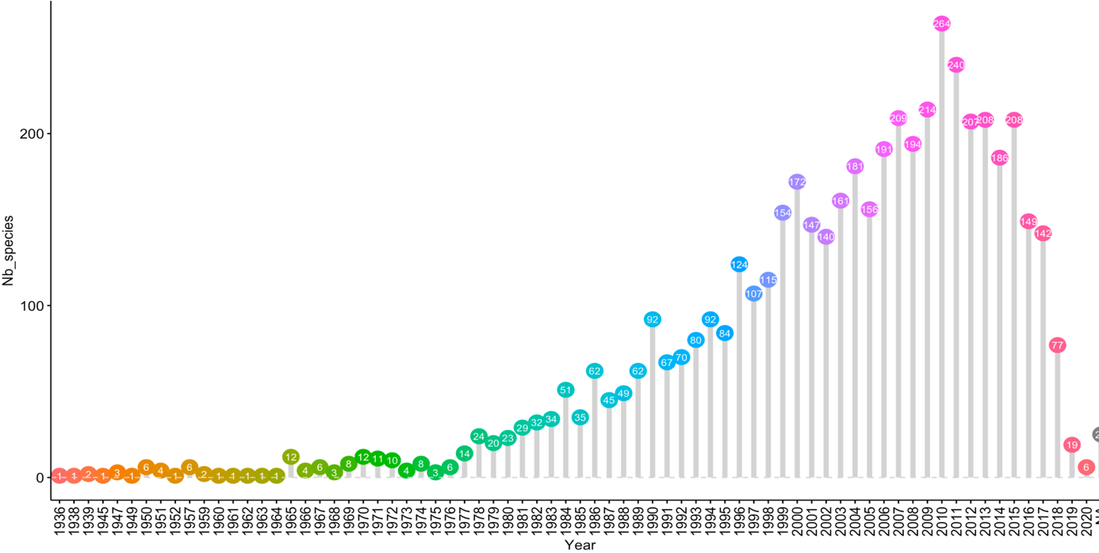

b.



Fig 2. Total number of species analyzed per year (a), and number of “new” species analyzed each year.

* To be compared with https://sci-hub.tw/https://doi.org/10.1073/pnas.1313490111 fig 1 ? + https://www.ncbi.nlm.nih.gov/pmc/articles/PMC6364885/#pone.0209788.ref007

A.



B.



Fig 3. Species present/analysed in the experiments when coffea arabica (a) or zea mays (b) is studied.

* to be detailed by region? Crop diversification strategies?
* Draw a global map of species analyzed together?



Fig 4. Proportion of primary studies analyzing the species vs. the area of cultivation of the species (world). Line represent 1:0.001

* colouring according to species families?
* Include all species?

**Literature:**

<https://www.sciencedirect.com/science/article/pii/S1360138516000601?casa_token=gqNAICuY3XwAAAAA:tRZf4r1HeLZ47WTNKkHDteNHgzbUv3OEiO6w8rb3APhMG1OYPHPHm2ZpGJi8ycDLimqctl-7#bib0080>

C.K. Khoury, *et al.***Increasing homogeneity in global food supplies and the implications for food security**

<https://www.ncbi.nlm.nih.gov/pmc/articles/PMC6364885/#pone.0209788.ref007>